**CIS2233**

**Database**

**Homework**

**Spring 2019**

Construct an E-R diagram for a car-insurance company whose customers own one or more cars each. Each car has associated with it zero to any number of recorded accidents

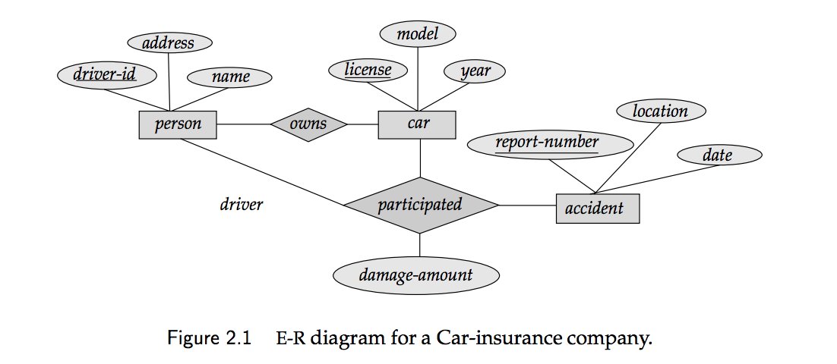

**Create a database from the E-R above. Insert some data into the tables and perform the following queries.**

**select person info given driver_id**

**select person_info given last_name**

**select person info living in California**

**select all the cars**

**select all cars >=2010**

**select all BMW cars**

**select all BMW cars with their owners**

**select how many accidents happened in this year**

**select how many accident happened last month**

**select all the accidents with BMW cars**

**select total damage_amount last year**

**select total damaged_amount with BMW cars**

**select all driver_id that had accidents last month**